MILLINGTON NURSERY SCHOOL

NOVEMBER 2023 NEWSLETTER

TOPIC – OURSELVES AND OUR FAMILIES
SHAPE – SQUARE
COLOUR – RED AND YELLOW (Autumn colours)

Please encourage your child to look around your home to see if they can find different squares, and objects that are red and yellow. Possible games you could play to support this could be Kim’s Game where one object is removed, and the children must guess what is missing or hunt the square shapes which have been hidden around the house. They could also look at photos of themselves as they were growing up, encourage the children to talk about the picture and their memories of a special event.

SAFETY REMINDERS
To ensure the safety of all our children, please make sure that everyone uses the pathway and not the car park gates when arriving and leaving school. Parents MUST NOT park within the school grounds.
In the mornings, please ensure your child is waiting beside you and not running round the area to the front of school as we don’t want anyone to have an accident before they come into school.

HOME - SCHOOL LIAISON MEETINGS
Parent and Teacher meetings this year will be held between 7th and 13th November. Times and dates have been allocated if you need to check your time please speak to a member of staff. These meetings are approximately 10 minutes each. Children should NOT be brought to these meetings. Please use the main front door to access the school.

HEALTH VISITOR MEETINGS
This second parent meeting is your child’s three-year review with the Health Visitor, these have been arranged for 15-17th November. This meeting will be held in our school and should last approximately 20 minutes. The children MUST be present for this meeting and be accompanied by a parent. You will have been given a separate date for this meeting, again speak to staff if you have misplaced the date and time. Parents, please use the main front doors, and collect your child from us five minutes before your start time if they are in school.
FULL TIME HOURS.
The children will leave for home at 12.45pm until Friday 10th November, to enable staff to conduct parent interviews.
From Monday 13th November children will stay for the whole day (unless other arrangements are in place). Collection time will begin at 1.00pm. Children MUST be collected BEFORE 1.15pm as staff have many other duties to attend to in the afternoon.

Dinner money
Dinners cost £2.50 each day. You may pay the amount weekly (£12.50) or monthly if you wish. If your child is absent and you have paid for a dinner the money will be carried over until the next week.

School Fund
School Fund is payable by everyone each week, this money is used to purchase the children’s break items, it is also used to purchase new toys and art equipment as well as treats for the children. School fund can also be paid weekly, monthly, or termly.
Dinner money and school fund should be payable on the first day of the week, usually a Monday, please place all money in the plastic envelope.

OPTICIAN VISIT
Every year we have been able to arrange for an optician from Mackey Eye Care to visit all three classes, to chat to the children about what to expect if they visit an optician. A date for this year has still to be confirmed.
During this talk the children will be given different types of glasses to try on and will try to identify pictures from their special eye charts. It is important for all children to have regular eye checks just like visiting the dentist, however the children do not get their eyes checked on this day.

FOOTBALL ACTIVITY SESSIONS BY SHINE SPORTS FOR ALL

We are planning to run football-coaching sessions for all the children, through our Extended Schools programme. A fully qualified IFA coach will lead each of these sessions. Developing the children’s fitness and physical development is vitally important part of our curriculum. (There will be no cost for these sessions)
Over the past few years, the children have really enjoyed these sessions and enthusiastically participated not only in the football skills but when back in the classroom extended their learning by using our play equipment to build football stadiums and paint pictures of them playing football. Hopefully this year will be even more fun!

Learning Focus Days
This year we are planning to hold two learning focus days. We will initially have a Jigsaw Day on Monday 13th November where the focus will be on developing the children’s ability to complete a puzzle. They will gain rewards for each puzzle they complete. We would love you to join in with this activity at home. Jigsaws are a brilliant tool for developing a range of early learning skills including fine motor control, hand eye coordination, focus and concentration, spacial awareness, pattern, and colour recognition.
We realise that puzzles can be expensive to purchase but are a brilliant present especially with Christmas approaching, but you do not have to go out to buy one, cutting out a picture stuck onto a cereal packet is a fun way to introduce puzzles at home. (Unfortunately doing a jigsaw type puzzle on an I-pad or tablet does not have the same learning value.)

Our second day on the 22nd November (weather permitting) we will hold an Outdoor play day, where the children will spend the day engaged in forest school activities including cooking around the campfire, and creating art using natural materials. On this day the children should wear warm clothing including a hat, waterproof trousers, and wellington boots if they have them, (please do not go out and buy these as they are not essential, school has a limited supply)

LENDING LIBRARY

BOOK BAGS
Each class has a set of book bags which we will be sending home this term. Each one contains up to 7 books for you to read to your child at home. Please take good care of these packs and ensure that all our books are returned to school in good condition. The packs will go home with the children on a Monday afternoon, please return them to school the following Monday morning. If you child is absent, please bring the bag back on the following Monday.

Barnaby and Millie bears
We have two bears that may go to visit your family for a few days over the next few weeks. The children love having them to visit. We would love you to take a few photos or bring in an item for your child to talk about when back in school. More details will go home with the bears later in the month.
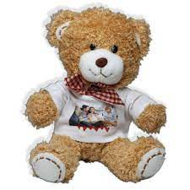

As part of Getting Ready to Learn we are hoping to purchase a range of PE equipment which we will also send home to help the children develop their physical skills, again more details will follow.

DATES FOR YOUR DIARY!
Christmas Jumper Day & sing along - Friday 15th December
Christmas Party - Wednesday 20th December
Last day of term - Thursday 21st December
(Children are to be collected between 10.45am and 11.00am on this day)

Regards

Mrs Millar, Mrs Savage, Mrs McKittrick, Mrs Stretton, and Mrs Curran

Tommy Thump is Up

Tommy Thumb is up
And Tommy Thumb is down.
Tommy Thumb is dancing,
All around the town.
Dancing on your shoulders,
Dancing on your head,
Dancing on your knees,
Then tuck him into bed.
Peter Pointer’s up
Toby Tall is up
Ruby Ring is up
Baby Finger’s up
Finger Family’s up,
Movements:
"Up": Point finger up.
"Down": Point finger down.
"Dancing": Dance finger around.
"Shoulders": Put a finger (or a finger on both hands) on your shoulder(s).
"Head": Put finger on your head.
"Knee": Put a finger on your knee.
"Tuck him into bed": Put both hands together and put your head on your hands and pretend you are sleeping.

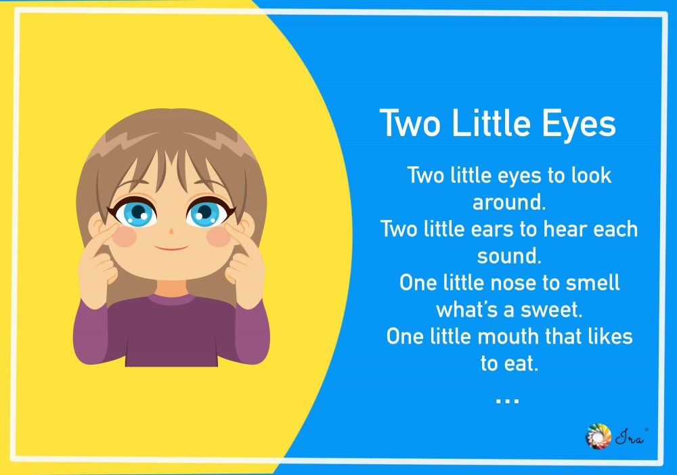
Ten Little Fingers
Ten little fingers, ten little toes,
Two little ears and one little nose
Two little eyes that shine so bright
And one little mouth to kiss goodnight

